**FORM Name – Mobile Request**

**Requestor Information: --- Section I – This section should be in**

**Variable set.**

**Reported by(Reference Field): -- Auto populate logged in user’s name.**

**Is the request for you: Yes/No**

**Reporting on behalf of(Reference Field): -- If yes, populate “reported by” value if NO then nullify and make user to select a user.**

**Request Details: -- Section II**

**Current Pole Location(Radio Button): US, EMEA**

**Company(list collector):- it should show values from core_company table.**

**Department Name(Reference): Pick only active records from cmn_department table.**

**Make & Model(multiple choice) : iPhone 4, iPhone 4s, iPhone 5, iPad 2, iPad 3, iPad 4**

**Direct Phone Number(Single line Text): --**

**Complete Location Details (AutoPopulate location of On “Reporting on behalf of” from cmn_location table):**

**Urgency (drop down): 1- Critical/2 - Moderate/ 3- Other(Include None)**

**Priority :- High/Medium/Low (Dependent on Urgency Value)( (Include None)**

**Help (More Information) – Priority field should display Help Information given below.**

High :- Single Site or Application Outage

Medium:- Application or Infrastructure Performance or Outage with a workaround. Not production

Low :- Single User.

**Short description(Single Line Text – 80 char):**

**Issue Details (Multi Line – 2000 char):**

**Note: All the fields marked in RED are mandate.**

**Client Scripts**

**OnLoad**:- Autopopulate reported by field value.

All fields marked in Red colour above should be made mandatory via On Load scripts.(Do not make them mandatory by default).

**OnChange** :-

On Change of Urgency Field Values should auto populate as show below.



**OnSubmit** – Attachment should be mandatory.

**Workflow** -- Mobile Request and attach it to the catalog item

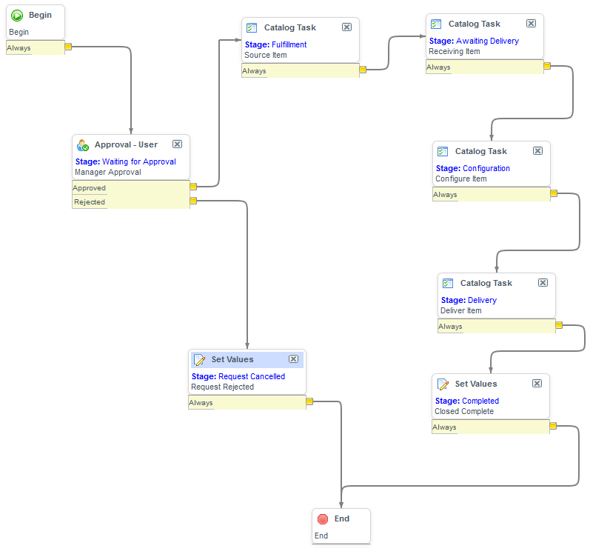

|  |  |  |  |  |  |
| --- | --- | --- | --- | --- | --- |
| **Workflow for Catalog Item** | | | | | |
| **Activity** | **Activity Type** | **Stage** | **Activity name (Short description)** | **Fulfiller** |
| 1 | Begin |  |  |  |  |
| 2 | Approval | Manager Approval | Approve policy | Manager of the requestor |
| 3 | Task | Fulfilment | Order from vendor or move from in-stock inventory | ITIL Grp1 |
| 4 | Task | Awaiting Delivery | Receive Item | ITIL Grp2 |
| 5 | Task | Configuration | Configure hardware and test system for initial bootup | ITIL Grp3 |
| 6 | Task | Delivery | Deliver the item | ITIL Grp4 |
| 7 | End |  |  |  |